SHANMUKA SREENIVAS AVULA  Consultant • AI / ML Engineer • Targeting Team Lead  Email: shanmukasreenivas9@gmail.com | Phone: +91-9701493308  Location: SR Nagar, Hyderabad, India  Web: iamshanmuka.com  LinkedIn: linkedin.com/in/shanmuka-sreenivas-718b87134  GitHub: github.com/shanmuka-flow | 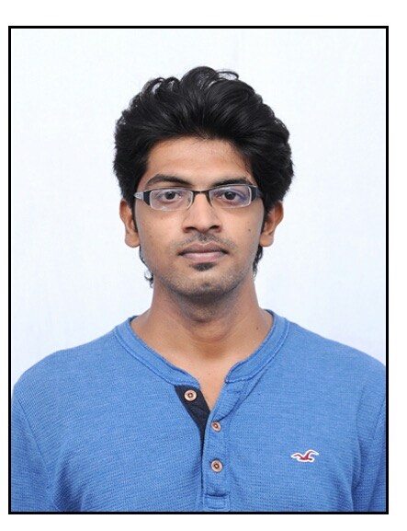

■ PROFESSIONAL SUMMARY
Results-driven AI/ML professional with 9+ years of experience delivering machine learning and data engineering solutions across energy, edtech, insurance, finance, and enterprise technology. Proven track record of leading cross-functional teams, mentoring developers, conducting AI proof-of-concepts, and shipping production-grade systems at scale. Promoted to Consultant at Deloitte after consistent technical delivery and client impact. Skilled at bridging complex AI research — reinforcement learning, graph neural networks, generative AI — into real-world applications. Seeking a Team Lead / Senior ML Engineer role to drive AI innovation and lead high-performing engineering teams.
■ TECHNICAL SKILLS
ML / AI | Classification, Regression, Clustering, LSTM, CNN, RNN, Reinforcement Learning, GNN, Knowledge Graphs, Generative AI, Transformers
Python Libraries | TensorFlow, Keras, Scikit-learn, Pandas, NumPy, Matplotlib, NetworkX, OpenAI Gym, FastAPI, SQLAlchemy
Cloud & DevOps | AWS Certified (Solutions Architect – Associate), S3, EC2, Apache Airflow, CI/CD, PROD Deployments
Databases | Snowflake, Teradata, MySQL, SQL
Tools | Python, Jupyter, Git, REST APIs, GenAI / LLM Prompting (Claude, ChatGPT, CodeWhisperer)
■ WORK EXPERIENCE
Analyst (Dec 2021) → Consultant (2023, Promoted) | Deloitte Consulting India Pvt Ltd Dec 2021 – Present
Hyderabad, India
- Joined as Analyst in Dec 2021 and promoted to Consultant in 2023 — recognition of consistent technical delivery and measurable client impact.
- Led team onboarding through KT sessions, mentored junior developers, and resolved technical blockers across project teams.
- Drove AI/ML POCs internally; conducted demos to educate stakeholders and champion AI adoption within delivery teams.
- Managed multiple PROD deployments and contributed to DevOps pipelines ensuring reliable, zero-downtime releases.
- Key engagements: Dell Digital (Continuity of Supply), Amazon CodeWhisperer, Bank of Montreal — see Key Projects for details.
Machine Learning Engineer | AGS Pvt Ltd (Affluent Global Services) Aug 2021 – Dec 2021
Client: Deloitte • Hyderabad, India
- Short-term contract engagement serving as the formal transition bridge to a permanent role at Deloitte Consulting India.
- Continued delivery on Liberty Mutual Insurance data migration project within the Deloitte client ecosystem.
Machine Learning Engineer | Skanda IT Services Pvt Ltd Jan 2021 – Aug 2021
Client: Deloitte • Hyderabad, India
- Contract engagement embedded within Deloitte delivery teams, working directly on client-facing projects.
- Initiated and delivered the Liberty Mutual Insurance Teradata-to-Snowflake data migration project.
- Built Python automation scripts for data migration and validation; created file-organisation utilities eliminating manual overhead.
Machine Learning Engineer | Metagogy Learning Systems Pvt Ltd Feb 2020 – Jan 2021
Hyderabad, India • (Shared founding team with Cybermotion Technologies)
- Independently researched and developed multi-approach ML system for knowledge gap identification in an EdTech platform.
- Deployed Reinforcement Learning model (OpenAI Gym) to production in 2020 — an early real-world RL deployment when production references were scarce.
- Built per-student knowledge graphs using NetworkX and Graph Neural Networks for personalised question delivery.
- Explored chatbot integration for interactive student learning support.
Machine Learning Engineer | Cybermotion Technologies Pvt Ltd Sep 2017 – Jan 2020
Hyderabad, India
- Designed and deployed end-to-end ML pipeline for real-time solar panel fault detection using LSTM on multi-sensor time-series data.
- Built multi-class classification system on voltage, current, frequency, and power factor data; deployed trained model to production.
- Solution enabled proactive maintenance and improved energy efficiency of solar water pumping systems by 30%+.
■ KEY PROJECTS
Dell Digital — Continuity of Supply
Deloitte Consulting India | 2023 – Present
- Designed and built 100+ FastAPI REST endpoints for supply chain data management covering inventory, supply, demand, and financials.
- Built an extensive Simulation Feature — users mock supply chain variables (CFG, part, site, region, GSM, supplier) and visualise expected outcomes in real time.
- Led team onboarding (KT sessions, resolving doubts) and coordinated multiple successful PROD deployments.
- Handled DevOps tasks for deployment pipelines; collaborated across cross-functional, multi-geography teams.
Tools: Python, FastAPI, SQL, DevOps, REST APIs, Git
Amazon CodeWhisperer — AI Data Preparation
Deloitte Consulting India | 2022 – 2023
- Prepared training data for Amazon CodeWhisperer by authoring diverse, semantically equivalent prompt–code pairs across AWS use cases.
- Ran internal AI demos and POCs; acted as AI champion driving generative AI adoption within the project team.
Tools: Python, AWS S3, Generative AI, LLMs
Bank of Montreal — Data Migration
Deloitte Consulting India | 2022
- Built and managed Apache Airflow DAGs for automated financial data pipeline orchestration across the migration project.
Tools: Python, Apache Airflow, SQL
Liberty Mutual Insurance — Data Migration
Skanda IT / AGS / Deloitte | 2021 – 2022
- Developed Python automation scripts to migrate large-scale financial data from Teradata to Snowflake with high fidelity.
- Built comprehensive data validation framework to detect and fix discrepancies caused by platform differences (special chars, type mismatches).
- Created file-organisation utility eliminating significant repetitive manual work for the team.
Tools: Python, SQL, Teradata, Snowflake, Pandas
EdTech Knowledge Gap Finder
Metagogy Learning Systems | 2020 – 2021
- Designed multi-approach ML system to identify student knowledge gaps and deliver adaptive, personalised learning experiences.
- Deployed Reinforcement Learning agent (OpenAI Gym) to production — among the earliest known RL deployments in EdTech.
- Built per-student knowledge graphs with NetworkX; triggered targeted reinforcement questions for weak concept areas.
- Explored Graph Neural Networks and chatbot integration for deeper personalisation.
Tools: Python, OpenAI Gym, NetworkX, GNN, LSTM, TensorFlow, Keras, Logistic Regression, K-Means
Smart Remote Monitoring — Solar Fault Detection
Cybermotion Technologies | 2017 – 2020
- Built multi-class LSTM classification model on real-time solar panel sensor streams (voltage, current, frequency, power factor) to detect faults early.
- Deployed to production; enabled proactive maintenance and improved energy efficiency of solar water pumping systems by 30%+.
Tools: Python, LSTM, TensorFlow, Keras, Scikit-learn
■ CERTIFICATIONS & COURSES
- AWS Certified Solutions Architect – Associate
- TensorFlow in Practice Specialization — Coursera
- Applied Artificial Intelligence Course — Applied Roots
- Generative AI & LLMs (Claude, ChatGPT) — Udemy
- The Ultimate MySQL Bootcamp — Udemy
■ EDUCATION
B.Tech — Electrical and Electronics Engineering
KORM College of Engineering | 2010 - 2014

